Design Document

# The Last Ninja

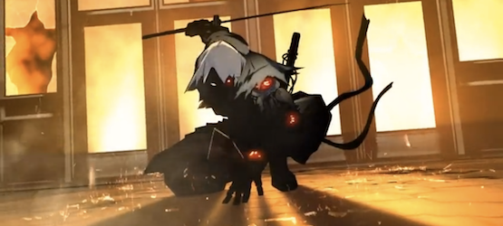 (Side Scroller)

*Developed By Ninjas Unlimited*

# Design History

This is version 2.0 of the document which began on February 4, 2014.

## Version 2.0

Draft of game design.

1. Refined from platformed to side scroller
2. Identified main objectives

# Game Overview

### Type of Game

This game is a side scroller with non-stop ninja-style combat.

### Game Ideas

Player takes the role of the last ninja. Player is beset on all sides by an unlimited number of enemies that generate at ever increasing rates. Player’s goal is to last longer than previous rounds.

### Location

2D battlefield. Location atmosphere is gloomy, ethereal, and Japanese-themed.

Players

Single player controls the last ninja.

### Main Objective

Survive.

### Game Overview

Use melee and projectile skills to fight off enemies.

# Features

## General Features

* Action-packed
* Stylized graphics
* Several types of enemies
* Infinite progression
* Persistent score

## Multiplayer Features

* N/A
* No plans to implement

## Editor

* No plans to implement

## The Game World

## Overview

Silhouette-stylized Japanese-themed battlefield.

### Key Locations

* The Last Stand Battlefield

### Objects

* Battlements—put on hold. Might not implement

Graphics

## 2D

Silhouette-styled graphics, primarily found

Parallax backgrounds and fog added.

## Models

Ninja - Standing

Ninja - Melee

Ninja - Moving

Ninja - Jumping

Ninja - Ranged

# Game Characters

## Main Character

There is only a single main character in the game.

## Enemies

There will be several enemies that you'll encounter:

Pikemen: infantry, medium health pool, melee only, basic ai

Pikeman changes to spearmen

Bowman: ranged, small health pool, mostly immobile

Samurai: tough, large health pool, TBD

Weapons

## Types

Melee sword

Ninja stars, ranged

Musical and Sound Effects

## Music

Stolen

## Sound Design

Looking to generate a ethereal, fight-for-your-life, atmosphere.

# User Interface

Keyboard driven. Arrow keys move, z and x attack (melee/ranged). While playing an indicator of progress will be displayed (time survived or enemies slaughtered.)

# Appendix ABC

Any additional information…. Ideas include:

# Team Members and Duties

Brian Thornton

John Schavey